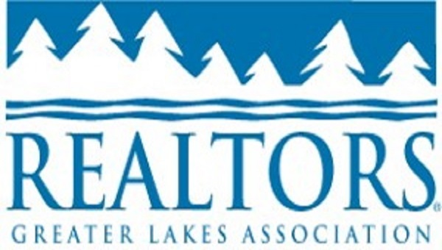
MLS Password and Security Agreement
Broker/ Agent

MLS passwords are distributed exclusively to those brokers and their agents who are participants of the Regional MLS, and those REALTOR® agents associated with them. These passwords are NOT to be distributed, loaned, or given to any other individual. Violations of this policy are to be promptly reported to the MLS committee or to GLAR. Improper use of MLS data is a very serious violation and subject to a $1,000 fine for first offense and double for subsequent offenses. These fines are subject to change and will coincide with any Northstar revisions.

By Signing, I agree to abide by the rules and regulations concerning MLS passwords and security. I understand that if I violate this policy, I will be subject to the above listed fines.

Broker/Agent Signature__________________________________________DATE___________________

Office________________________________________________________

